How to Reset Windows Server Password when your computer is not the Domain

Article Source:

http://recoverlostpassword.com/article/reset-windows-server-password.html

Windows Server operation system, released by Microsoft Corporation, is the platform for establishing a substructure of networks, connected applications, and Web services, from the workgroup to the data center. How could you get access to your Windows Server system when you forgot your Windows Server login password? How to reset Windows Server password in Windows Server 2008(R2)/2003(R2)/2000 local password when your computer is not the Domain?
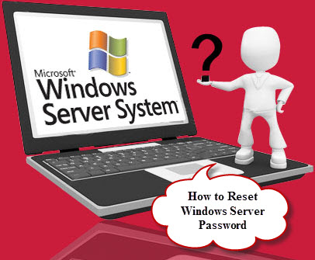
Windows Server login passwords of the computer are Windows local passwords, not domain passwords. So when you forgot Windows Server password and cannot get access to the computer, you can turn to Windows Password Recovery Software for help, which allows the people who forgot Windows Server password to reset the passwords for Server 2008(R2)/2003(R2)/2000 by burning a Windows Password Reset CD/DVD or Windows Password Reset USB flash drive.
Reset Windows Server Password with SmartKey Windows Password Recovery
Fortunately, a lot of computer technologies have found the Windows Server Password solution, like SmartKey working team. SmartKey official site has released a product called Windows Password Recovery Professional which enables you to reset Windows local password on Windows 7/Vista/XP and Windows Server 2008(R2)/2003(R2)/2000 with a Windows Password Reset CD/DVD or Windows Password Reset USB flash drive.
Now follow this tutorial to Reset Windows Server Password:
Things you need to prepare in advance
1. A good PC that can link to the Internet
2. A blank CD/DVD or USB drive
3. Download Windows Password Recovery Professional at first.

After downloading and installing Windows Password Recovery Professional in a PC that can link to the Internet, and then follow the user guide listed below to Reset Windows Server password.
Step 1: Burn a Windows password reset CD/DVD or Windows password reset USB flash drive.
- Choose “Reset Windows Local Account Password” mode
- Insert a CD/DVD or USB flash drive into the computer. Select “CD/DVD” or “USB Flash Drive” to burn the Windows Password Recovery Professional program. Here takes “CD/DVD” for example.
- Click “Burn” button to start burning.
- Click OK when the burning task completes. Now you have successfully created a Windows password reset disk.
Step 2: Set BIOS to boot from CD/DVD or USB Flash Drive.
Note: The keyboard pressed to enter into BIOS is different based on manufacturers, but often F2, Delete and F10 are work.
Step 3: Reset lost Windows Server password.
When the computer successfully boots from CD/DVD, you'll see SmartKey Windows Password Recovery Professional is initializing. Then you'll find that all Windows account user names are displayed.
1. Choose the user account you wish to reset.
2. Click “Reset” button to process the Windows password resetting course
3. Click “Yes” to confirm your operation.
4. Click “OK” when the password is successfully reset.

You'll find that Your Windows Server password has been reset to a known one. Click Reboot to restart your computer. When the computer restarts to Windows logon screen, select the target account user name and log on to it with the reset Windows Server password.

